Presenting your mare for Classification
You will want to give your mare the best opportunity possible to score well in her inspection. To this end, there are certain steps you can take that will be to her advantage:
Ideal preparation of the mare
It is necessary that the mare be trained in presentation and handling in the walk and trot. Regular lungeing for a period before the Classification day will be an advantage in presenting the mare fit, well and in good condition.
Have the mare well presented – well groomed, shiny coat, clean hooves and preferably plaited.
What happens?
The mare Classification always takes place on a triangular course. The first step is the individual inspection. You place the mare at a distance of about 4 – 5 metres in front of the classifiers, in the so-called open position (see diagram).

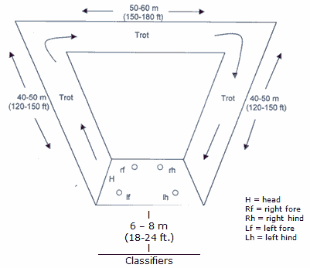
At this time the Classifiers give the individual marks for conformation.
Then you are asked to trot one lap with the mare. The Classifiers remain in the same place, and because of the triangular nature of the course they are able to inspect the mare first from behind (moving away from them), then from the side, and finally from the front (moving towards them). For this to work, however, it is necessary to follow exactly the triangular form of the course. (see diagram above)
At the trot, the mare should be given the chance to move as freely as possible. This requires that the exhibitor should be someone who is athletic enough himself or herself to give the mare the best opportunity.
After the trotting lap, the mare is turned once again and presented to the Classifiers standing with the right side facing.
At some point, the Classifiers will ask that the mare be led directly away from them at the walk, and then directly back towards them, usually on a path that bisects the triangle. This is to assess the correctness of the gait at the walk.
The presentation to evaluate the ground covering quality, rhythm and swing at the walk follows, with a number of mares presented walking in a large circle. The walk should also be shown as freely as possible.

