Stallion Licensing/Performance Testing Protocols

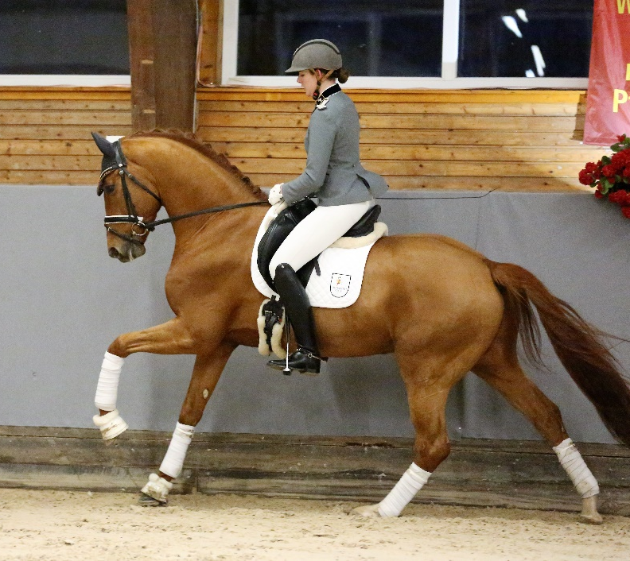

Contents
Contents 1
How to Apply for Stallion Licensing 1
What Costs Are Involved 3
Professional Test Riders 3
The Normal Rider 3
The Testing Venue 3
Official Results 3
Licensing Procedure 4
Veterinary Report 5
X-Rays 9
WFFS Testing 10
Stallion Performance Testing 11

How to Apply for Stallion Licensing
If you are a stallion/colt owner and wish to put your stallion up for licensing, you will need to complete an Application for Stallion Licensing online. The aim is to conduct licensing as part of the National Tour, with nominations closing at least one month prior to the start of the Tour, normally February/March. A copy of the required form can be found on the HHSA website at www.hanoverian.org.au. Please note you must also be a financial breeder member.

What Costs Are Involved
If the stallion is already licensed in Europe, we only charge for travel to the venue for the Commission.
For stallions who are not licensed by a European breed society, the cost is $1500 for each stallion to be assessed by the Commission. This fee covers the cost to employ professional Test Riders, Live streaming to Germany (if required) and travel costs of the Licensing Commission.

Professional Test Riders
The HHSA in conjunction with the Hanoverian Verband nominates a Test Rider for the stallions. It is important that each test be carried out in a professional and unbiased manner. For this reason, only riders who do not have close connections with either the horse and/or the owner are employed.

The Normal Rider
It is the responsibility of the stallion owner to provide a rider for their stallion. For the best results, the rider should be familiar with the stallion and training should have been conducted on a level commensurate with the age of the horse and the training scale for this age.

The Testing Venue
Each year, the testing venue/s will be decided by the HHSA Committee. The venue must have a full-size arena, preferably indoor. Jumping lanes need to be constructed and these can be either indoor or outdoor. Sufficient stabling and/or secure yards are also necessary.

Official Results
Official results can only be released once all sections of the testing are completed. It may be necessary for videos that have been taken on the day to be sent to Germany for review before results are released.

Licensing Procedure
For a stallion to be considered for licensing, the dam as well as her own dam must be registered in the Main Stud Book, the great-grandam on the dam’s side must at least be registered in the Stud Book:
1stGeneration | 2ndGeneration | 3rd Generation
Sire
(Licensed & Performance Tested Hanoverian Stallion or Stallion from another Studbook who has been Approved for Hannover)
Dam
(Main Studbook)
Dam’s Dam
(Main Studbook)
Great Grandam
(Studbook)

Licensing is the decision taken by the Hanoverian Horse Society of Australia or the Hannoveraner Verband and its associated daughter societies concerning the provisional use of a stallion within the context of the breeding program. In making the decision, the features of the external appearance as well as the performance potential are considered particularly carefully in as far as these are evident from the available information.
The licensing decision is as follows:
LICENSED | NOT LICENSED

The decision concerning licensing is to be passed on to the owner of the stallion in writing. The notation “Licensed” is to be entered into the pedigree papers.
The licensing is to be withdrawn if a condition for granting it was not met with at the time; is to be revoked if one of the requirements subsequently lapses; may be revoked if a condition was attached to the licensing and the owner has not fulfilled it or not done so within the required period of time.
The stallion owner is entitled to file an objection to the licensing decision. This must be done within a period of four (4) weeks after the decision has been made known. This must be done in writing and include reasons.
The Committee shall nominate a new Evaluation Commission, all members of which, apart from the Breeding Director, are to be newly appointed. The decision shall also be taken concerning the place and time of the new presentation of the stallion.
The dates of the licensing and how they are to be conducted is to be laid down by the Committee.
Young colts or stallions from 2½ years may be presented for Pre-Licensing where an evaluation of their suitability for breeding stallions will be assessed.
The Committee decides where the licensing shall be held and who the classifiers who comprise the Evaluation Commission shall be. The Evaluation Commission decides on the provisional licensing of the colts.
The colt to be licensed should be presented prior to the actual licensing to the Registrar of the Society who will confirm the identity of the horse when compared with its original pedigree papers. The horse will also be measured.
Both the handler and the whip assistant must wear Hanoverian/Rhineland polo shirts which are available from the Society. There is only one whip assistant allowed per stallion.
The following areas are evaluated at the licensing:
- Free running with evaluation of the canter.
- Free jumping with three jumps - both technique and ability (scope). For Dressage bred stallions free jumping is not compulsory.
- Evaluation of the walk in hand over half a long side of the arena at the completion of the free jumping.
- Presentation on a hard surface. On this occasion, conformation marks are given and the correctness of the legs is judged.
- Presentation of the individual colt at the trot on the triangle.
- Walking the colts/stallions in a group of up to ten stallions on a large circle around the triangle.
In addition to the above steps, four-year-old stallions should be presented under saddle in groups of four horses if possible. The gaits and rideability will then be assessed. The impression under saddle will be included in the scores for the individual gaits, the impression of rideability will be included in the score “overall impression”. On a voluntary basis, the stallions may also be shown over four jumps under saddle.
The stallion will be considered to be licensed if has been awarded an overall mark of at least 7 (7.5 if non Hanoverian) and he must not score lower than 5 in any individual criteria.
The criteria are as follows:
1 | Breed & Sex Type
2 | Conformation
 | - Head
 | - Neck
 | - Saddle Position
 | - Frame
 | - Forelegs
 | - Hindlegs
3 | Correctness of Gaits
4 | Swing & Elasticity of the Trot
5 | Canter
6 | Walk
7 | Free Jumping
 | - Technique
 | - Scope
8 | Total Impression & Development

Marks are awarded out of ten on the following scale:

10 | Excellent | 4 | Deficient
9 | Very Good | 3 | Poor
8 | Good | 2 | Quite Poor
7 | Fairly Good | 1 | Very Poor
6 | Satisfactory | 0 | Not Evaluated
5 | Sufficient

Stallions licensed at a licensing of the Verband or its daughter Societies will have this result recognised by the Society in Australia.
In order for a colt to be accepted for licensing, the following conditions are to be fulfilled.
- He must be at least three(3) years old.
- His ancestry must correspond to the conditions for registration in the Stallion Book.
- Original pedigree papers must be forwarded to the Society.
- The horse must be DNA.
A satisfactory veterinary report and x-rays must be furnished by the owners of the colt prior to the licensing.
Veterinary Inspection
It is an essential condition to be fulfilled to be permitted to take part in the licensing as well as for the licensing itself that the colt or stallion should show no deficiencies in health which would have a negative influence on his breeding ability and breeding value.
Before forwarding a formal application for licensing, the owner should contact the Society to signify their intention of presenting a colt for licensing. The veterinary inspection should be undertaken approximately one month before the Licensing. However, if the horse is to be DNA typed, owners should be aware that it may take longer than six weeks to receive the results of the DNA typing and should be prepared for this well in advance.
The Society will notify the owner of a veterinary surgeon nominated by the Society for the purpose of conducting a veterinary examination. Once in receipt of a satisfactory veterinary report and x-rays, the owner may then lodge a formal licensing application with the appropriate fees.
The veterinary report covers such areas as whether the colt/stallion is free from abnormalities of the sexual organs such as chryptorchidism, small testes, unequal testes, abnormalities of the epididymis. The colt/stallion should be free from abnormalities of the teeth and conformation as well as symptoms, which give reason to suspect proneness to hereditary diseases. The colt/stallion should be free from such major unsoundness such as staggers, broken wind, roaring, glanders etc. It must also be free from vices such as windsucking, weaving etc.
The horse may not have undergone any procedures to correct any abnormalities or vices such as denerving, operations to correct ossifications, etc.
The owner must declare whether the horse has been medicated in the previous 45 days prior to the veterinary examination and, if so, what medications of any description and in what doses have been administered to the horse.
If a negative result in any of these areas is detected, the veterinary surgeon should give full details and, if necessary, refer the horse for a second examination by a team of veterinary surgeons or at a university. Endoscopies should be taken when any abnormalities are suspected.
The veterinary surgeon should take the horses markings including brands and include those on the Certificate of Examination form so that the horse’s identity can be ascertained. The form below should be forwarded or printed and given to the Vet for completion. Once complete send to hanoverian@hanoverian.org.au.

Verband hannoverscher Warmblutzüchter e.V. (reg.Soc.)
Lindhooper Str. 92, 27283 Verden, Germany

(Address of Veterinary Surgeons incl. tel. no)

Report of clinical examination of the stallion
Life number Date of birth
Sire Dam

Markings

Owner/proprietor

o.b.B. = ohne besonderen Befund = without special results/findings
Bsh = Besonderheiten = Peculiarities/ exceptional features/qualities
Ja = Yes , Nein = No
Hengst LN = Stallion Life Number
Hals-/Schenkelbrand = Neck and/or thigh brand

- Feeding and care condition, behaviour
- Circulatory and respiratory system at rest, … after strenuous exercise
Spontaneous coughing
- Eyes (darkened room)
- Nose, mouth, ears
Parrot mouth
- Head, neck, body, back
(adspection, palpation)
- Exterior urinary and sexual organs
Are major defects of sexual organs present?
If necessary, further examinations
sonographic measurement
Right testicle Length: breadth/width: height:
Symmetry: Consistency:
Left testicle Length: breadth/width: height:
Symmetry: Consistency:
- Skin, noticeable scars
- Muscular and skeletal system
Shoeing ?
Special shoeing?
- Presentation in walk and trot on hard ground, rein back
- Neurological disorders, e.g. indication of Ataxia-(Wobblers Syndrome)-Shivering
- Presentation in walk and trot on a circle
… on hard ground
… on soft ground
Turning pain
- Inspirational noise during and after strenuous exercise
Type of breathing
If necessary further investigations (e.g. endoscopy, sonography, laryngoscopy)
Finding (according to Ohnesorge):
without finding: even/regular movement of aryteroide cartilage
slight: abduction of aryteroide cartilage reduced by up to 1/3
medium: abduction of aryteroide cartilage reduced by up to 2/3
high grade: abduction of aryteroide cartilage reduced by more than 2/3
Other findings
Sedative
- Other examinations and remarks: Finding:
- Witness of examination

* w.s.r./f. = without special result/findings Pec. = peculiarities: protocol no.
• (operations/surgery indicated by the owner, see declaration of owner)

Further examination recommended:
Team:
Veterinary College:
Reason for examination:

This veterinary certificate forms the basis for the licensing or the sale, respectively, of the stallion by the Verband hannoverscher Warmblutzüchter e.V. (reg.Soc.) Lindhooper Str. 92, 27283 Verden, Germany. The certificate is sent to the Verband hannoverscher Warmlbutzüchter e.V., Lindhooper Str. 92, 27283 Verden/Aller by the veterinarian.

Address of veterinary surgeons incl. tel no.

Place of examination: Date:

X-Rays
The following should be given to the Vet taking the X-Rays. Note 3 x-rays per hock. The x-rays need to be sent to Germany for approval prior to the licensing so please do a few weeks before the day. Please make sure your vet understands the angles on the protocol or Germany will not accept the x-rays and they will need to be redone. Shoes must be removed for the x-rays. A digital copy of the set of x-rays should be sent to hanoverian@hanoverian.org.au. Please check all x-rays required are included.
The Hanoverian Society’s x-ray protocol is based upon the society’s studbook reciprocity with the Hannoveraner Verband. In order to proceed to the licensing, the owner of a stallion candidate must provide the following required radiographic views:

- P3/Navicular (Fore limb only)
  - Lateromedial (Must be elevated on a block to evaluate the entire hoof).
  - 60° dorsoproximal-palmardistal oblique, commonly known as a DV (Must have clear interpretation of the navicular bone, shoes must be removed if unable to view the navicular bone in its entirety).

- Fetlock
  - Lateromedial (flexed in fore limb, standing in hind limb, clearly visualizing the sagittal ridge of the distal cannon).
  - Dorsal 10° proximal-palmar/plantarodistal oblique, commonly known as a DP (elevating seasmoids apart from P1 visualizing the distal cannon).

- Tarsus
  - 45° dorsomedial/posteriorlateral oblique (highlighting the distal intermediate ridge of the tibia and the distal lateral trochlear ridge of the talus).
  - Dorsoplantar view at 10° lateral (highlighting the medial malleolus of the distal tibia).

- Stifle
  - Lateromedial (including the patella)
  - Caudal 60° lateral-craniaomedial oblique (highlighting the medial femoral condyle in its entirety).

- There is no longer a grading system. Based upon the findings of the radiologists, the stallion’s x-rays will be determined to be either acceptable (i.e. horse may proceed to the licensing) or not acceptable (horse will be withdrawn from the licensing). A description of the radiographic findings will be documented.

- Any invasive joint surgery that has been performed must be reported when the radiographs are submitted. Pre-operative radiographs of the specified joint or joints must be included.

- With regard to OCD: Stifles must be free from positive finding. Bilateral OCD fragments in the tarsi are not acceptable. Severe/extensive OCD fragments in a tarsus or a fetlock are not acceptable. One fragment in a tarsus and one further joint, excluding the tarsus or stifle, is acceptable.

- Stallions will not be deemed acceptable with severe navicular or spavin changes.

Delivery
All studies must be in DICOM format. JPEG images will not be accepted. Radiographs should be emailed to: hanoverian@hanoverian.org.au. If preferred, DICOM files can also be sent via jump/flash drive to:

HHSA Registrar
303 Tallegalla Rd, Tallegalla, QLD 4340
Mobile: 0407 144 403
Whether delivered via email or regular mail, please include the name of the horse and his registration number along with the owner’s and veterinarian’s names and phone numbers.

NOTE: Stallions who have had x-rays completed and approved by another German registry may be exempt from this step in the process. Please call the HHSA Registrar for details.

WFFS Testing
Each stallion must be tested for WFFS. A carrier result does not affect the eligibility for licensing. However, if licensed the result will be published on HHSA advertising.

Stallion Performance Testing
Stallions from 3 years of age and older can be presented for licensing.
However, stallions without performance must be presented between three and six years of age.
Procedure:
- Presentation at hand, presentation on hard surface, free jumping (for young dressage stallions as well as for younger jumping stallions who cannot yet be jumped under the rider), presentation under the rider different according to age and to discipline. 5-year-old stallions have the choice to jump under saddle or in free jumping. Detailed notes on Free Jumping can be found on our website under Mare Performance Testing.
- 4 and 5-year-old dressage stallions should be presented with a test that is age appropriate.
- 6-year-old stallions should perform the FEI test for 6-year-old horses. Four to six-year-old jumping stallions should complete a course according to their age, i.e. the obstacle height varies between 110 and 130 (as above for jumping stallions)
- 6-year-old and older dressage stallions can be excused from the jumping component.
- To be presented with a snaffle bit in hand and under saddle. No boots or bandages when gaits are judged.
- Licensing committee: It should consist of a representative of the Hanoverian Association Australia or New Zealand, a representative of the German Hannoveraner Verband, as well as at least one disciplinary expert for dressage, jumping and/or eventing.
- If a young stallion gets licensed, an entry in the Stallion Book 1 can be made temporarily.
- The license becomes permanent if the following performance requirements are fulfilled in competition (young-horse classes):
  - Dressage: in defined young horse championships at age-appropriate level, a score of 8.0 or better must be achieved at the age of 5 or 6.

  - Show jumpers: in young horse classes at age-appropriate level, a yet to be named number of clear rounds were completed in one season, possibly in combination with final placings".
If the stallion does not pass the Performance Test or the Performance Test option is not available, stallions may pass the standards required for full registration in the Stallion Book through competition. This may be done at any age.
The stallion may be licensed and have had this lapse or the stallion’s owners may choose to present him for licensing after the achievement of the competition standards.
The required standards are five placings 1st to 3rd in jumper classes 1.4m or higher, or FEI Dressage (Prix St Georges at 65% or above), or three placings 1st to 3rd in a Three Day Event at Medium or Advanced Level. (i.e. CCI** and CIC** upwards).
Stallions registered with another recognized Warmblood breeding association must gain higher scores to be accepted which is determined by the Hannoveraner Verband guidelines.

